

**WIX1002**

**FUNDAMENTALS OF**

**PROGRAMMING TECHNICAL**

**REPORT**

**GROUP ASSIGNMENT**

**TUTORIAL: 2**

**GROUP: 3**

**LECTURER’S NAME: DR. NOR BADRUL ANUAR BIN JUMAAT**

**GROUP MEMBERS:**

|  |  |  |
| --- | --- | --- |
| **NO.** | **NAME** | **MATRIC NO** |
| 1 | TEE QI JING | 23004894 |
| 2 | TEE QI BIN | 23004909 |
| 3 | LAU DUAN HANG | 23005003 |
| 4 | AVIJIT CHANDRA DEY | 22089638 |

**TABLE OF CONTENTS**

PROJECT DESCRIPTION 2

Project Title: CODE FOR NATURE 3

Title Description 3

Problem Statement 3

PROJECT REQUIREMENTS 3

System Requirements 3

Game Requirements 3

Game Objects 3

Game Mechanics 5

Extra Features 6

PROJECT APPROACH 6

Pseudocode 6

Flow Chart 13

GAMEPLAY SCREENSHOTS 28

SOURCE CODES 31

APPENDIX 38

# PROJECT DESCRIPTION

## Project Title: CODE FOR NATURE

## Title Description

## Nature faces many challenges today, including climate change, pollution, and

## deforestation. These challenges are interconnected and have a devastating impact on

## biodiversity and the ecosystems that we rely on.

## One of the biggest problems is that many people are unaware of the nature problems

## around them. This is because nature problems are often complex and difficult to

## understand. Additionally, people may not feel connected to nature, so they may not be

## motivated to take action to protect it.

## Another problem is that it can be difficult to find ways to contribute to the protection

## of nature. Many people feel like they are too small to make a difference. Additionally, it

## can take time to figure out where to start.

## Problem Statement

Build a tower defense game in JAVA programming language which allows the player to protect the residents within the wall from the titans.

# PROJECT REQUIREMENTS

## System Requirements

● JAVA Programming Language

## Game Requirements

### Game Objects

* Wall
  1. 10 unit walls, each unit has 50 HP(Hit points/Health)

○ Whenever any wall unit has it’s HP equal to 0 or lower, the player loses

* Coin
  1. The only resource in the game

○ Initial number = 50 coins ○ Add 5 coins every hour

* Weapon
  1. There’s weapons on the walls

○ Each wall unit has 1 weapon

○ Weapon has 3 levels, different levels come with different attack points

○ Level 1 = 2 attack points, Level 2 = 5 attack points, Level 3 = 10 attack points

○ To upgrade the weapon to level 1, the player has to pay respective number of coin based the damage of the next level

○ To upgrade the weapon into level 1(attack = 2 points), 2 coins required

○ To upgrade to level 2(attack = 5 points) 5 coins required

○ To upgrade to level 3(attack = 10 points) 10 coins required

○ Visualize the weapons on walls

* Ground
  1. 10 units X 10 units

○ In front of the walls

○ Titans only can position on the ground

* Titans
  1. There are 2 types of titans

○ Colossus Titan and Armoured Titan

○ They take damage when there’s weapon on the lane the titan position at

○ Overlapping Titans printed as “AC”

* Colossus Titans
  1. Only show up on row 9

○ Show up after 5 hours

○ HP = 50, Attack = 10 points

○ Move left or right randomly

* Armoured Titans
  1. Only show up on row 0

○ Show up after 5 hours

○ HP = 100, Attack = 5 points

○ Move closer to walls after every hour (randomly left or right)

○ When he reaches row 9(in front of the wall), Armoured Titan destroys the weapon on his lane

○ When there’s no weapon on the wall where Armoured Titan position at, he moves closer to the wall with weapon by 1 unit

○ When he’s moving, he won’t damage the wall

○ When there’s no weapon on the wall, Armoured Titan starts to damage one wall unit, not moving left and right

### Game Mechanics

● Game rules

○ The Game started on Hour 0

○ Print the wall and ground

○ For each hour, the enemy and the player takes turns

○ After enemies’ turn, the player will be given options

○ First question: Choose the weapon(s) you would like to upgrade (Type a string of integer or hit Enter to skip)

○ Second question: Do you want to upgrade all walls? (press 1 if yes, press Enter if no) Current coin number: [current coin number placeholder]

○ Third question: How many HP do you want to add up to the wall(s)? Current coin number: [current coin number placeholder]

○ If the player chooses walls in the third question(e.g. the player type 1234 indicating that he/she wants to add the HP of wall units 1, 2, 3 and 4.), show the question: How many HP do you want to add up to the wall(s)? Current coin number: [current coin number placeholder]

○ If the coins are not enough to upgrade all weapons selected, the system will try to upgrade as many weapons as possible

### Extra Features

* Dynamic difficulty curve which is directly proportional to player’s in-game progression
* GUI Implementation which provides an immersive experience with great graphics
* Intelligent Armoured Giant with an improved, targeting behaviour
* In-game object animation ● Leaderboard

# PROJECT APPROACH

## Pseudocode

Design a game interface entitled **ATTACK ON TITAN PARALLEL WORLD**

Display GUI for the starting interface

Display a “Play” button which will open new window

Accept player name input

Display a “Leaderboard”, “Instruction” and “Let’s begin” button

Display leaderboard if leaderboard button is pressed

Display instruction if instruction button is pressed

Start game if “Let’s begin” button is pressed

Int hour = 0

Int coin = 50

Print map

Display map GUI

Print wall

Display wall GUI

Create 10 walls with different index from 0 to 9

Display wall index for all walls accordingly

Int wallHP = 50 for all walls

Display wallHP for all walls accordingly

Int wallLevel = 0 for all walls

Int wallAtk = 0 for all walls

Store initial info (wallIndex, wallLevel, wallHP) for all walls inside wallInfo

While wallHP > 0 for each and every wall

If hour<5 and is odd

hour++ coin +=5 Continue

Elif hour is odd and >=5

Sout(“Titan’s turn”)

For each round, chance to spawn Titan = (hour)/15

If chanceToSpawnTitan <1

Spawn Titan according to the chance

Elif chanceToSpawnTitan >1

Spawn (chanceToSpawnTitans/1) Titans

Read AAXY, CCXY, ACXY

If there is entry in AAXY

Read AAXY

If titanY != 9

titanY –

Else

If wallLevel of wallIndex(titanX) !=0 wallLevel of wallIndex(titanX) =0

Store info in wallInfo

Break

Elif wallLevel of wallIndex(titanX) ==0

Check wallIndex(i)

If wallIndex(i) has weapon titanX approach i by 1 unit Break

Elif all wallLevel == 0

wallHP of wallIndex(titanX) -= 5

Store info in wallInfo

Break

Store updated data in AAXY

If there is entry in CCXY

Read CCXY

wallHP of wallIndex(titanX) -=10

Store data in wallInfo

Get random number

If num == 0

Break

Elif num ==1

titanX -- Else

titanX ++

Store updated data in CCXY

If there is entry in ACXY

Read ACXY

If wallLevel of wallIndex(titanX) !=0 wallLevel of wallIndex(titanX) =0

Store info in wallInfo

Break

Elif wallLevel of wallIndex(titanX) == 0

wallHP of wallIndex(titanX) -= 10

Store info in wallInfo

Break

Store updated data in ACXY

Get a random number from 0~2

If rnum == 0

titanType = “AA” titanX = random wallIndex with weapon except occupied coordinate titanY = 0 titanHP = 100

Store new AA info(titanX, titanY, titanHP) in AAXY

Print Titan with coordinate titanX, titanY on map;

Else titanType =”CC” titanX = random wallIndex except occupied coordinate titanY = 9 titanHP = 50

Store new CC info(titanX, titanY, titanHP) in CCXY

If titanX, titanY of AA and CC are equal

Read AAXY and CCXY

Delete AA and CC in AAXY and CCXY

Add new AC into ACXY

Int titanHP = sum of current hp of AA and CC

Store coordinate, titanHP into ACXY

Else

Sout(“Player’s turn.”)

//Q1

Sout(“Choose the weapon(s) you would like to upgrade (Type a string of integer or enter “Go” to skip)”) User input string of int

Read str input as int

Read from wallInfo

If input == wallIndex wallLevel of the wallIndex ++

Elif input == “”

Break

Else

Sout(“Invalid input.”)

//Q2

Sout(“Do you want to upgrade all walls? (press yes or no) Current coin number: ” + gold or enter “Go” to skip)

If yes

Jump to Q3b with string of int = all wallIndex

//Q3a

Sout(“How many HP do you want to add up to the wall(s)? Current coin number: ” + coin or enter “Go” to skip)

If input == ignorecase“Go”

Break

Elif input == string of int

//Q3b

Sout(How many HP do you want to add up to the wall(s)?

Current coin number: “ + coin)

User input = amount

For all walls

If charAt(input) == wallIndex

Read info from wallInfo

If coin >= amount wallHP of wallIndex += amount coin -= amount

Else

Sout(“Not enough coin.”)

Write data in wallInfo

Else

Sout(“Invalid input.”)

For all titans

If Titan = “AA” or “CC” and wallLevel !=0 titanHP of the 1 st  titan on the titanX row – wallAtk(titanX)

Sout the remaining HP of Titan

Elif Titan = “AC” and wallLevel !=0 titanHP of the 1 st  titan on the titanX row – 2 * wallAtk(titanX)

Sout the remaining HP of Titan

coin +=5 hour++ Get hour

Get coin

Display hour

Display coin

If wallLevel for wallIndex(n) != 0

Display weapon GUI on nth wall

Switch wallLevel(n)

Case 1

Display wallLevel1 weapon GUI wallAtk =2

Case 2

Display wallLevel2 weapon GUI wallAtk =5

Case 3

Display wallLevel3 weapon GUI wallAtk =10

Repeat for whole string

Print updated wall and map

## Flow Chart

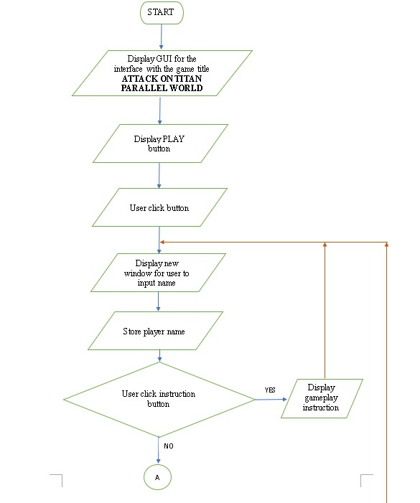

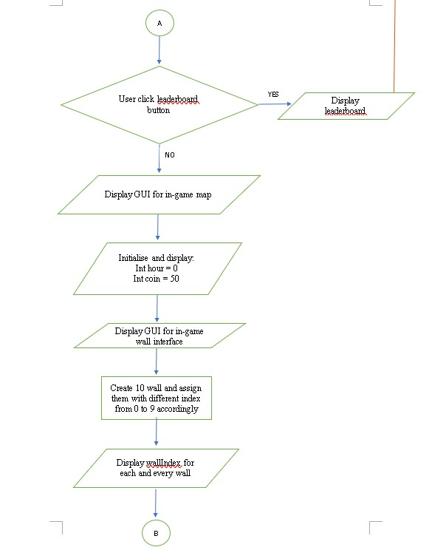

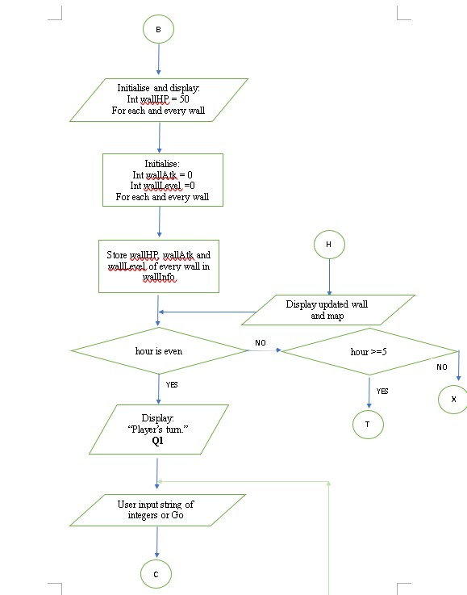

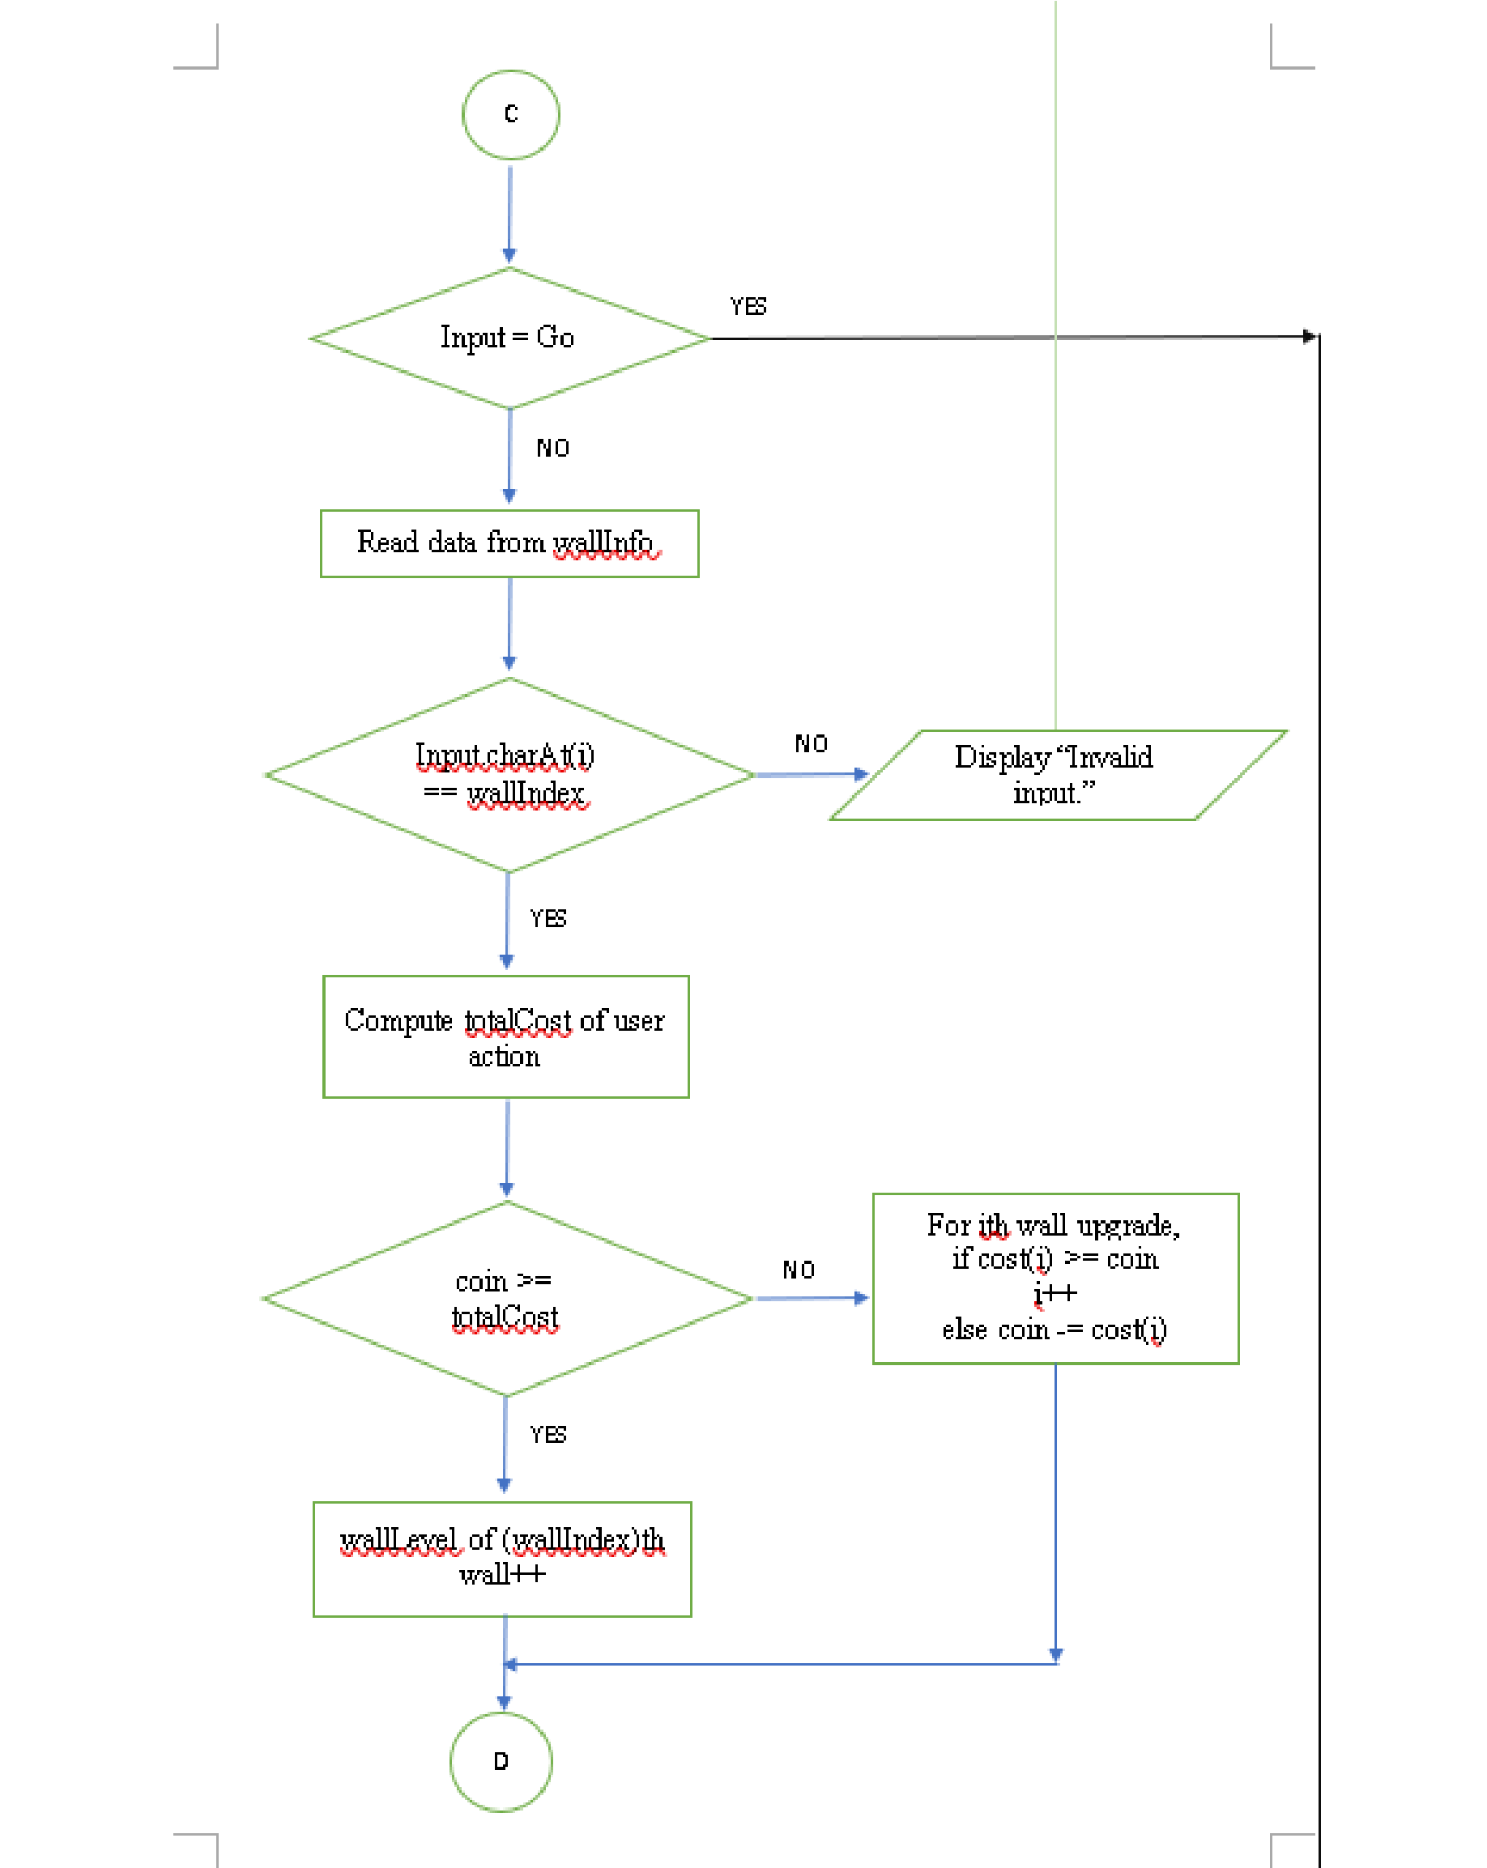

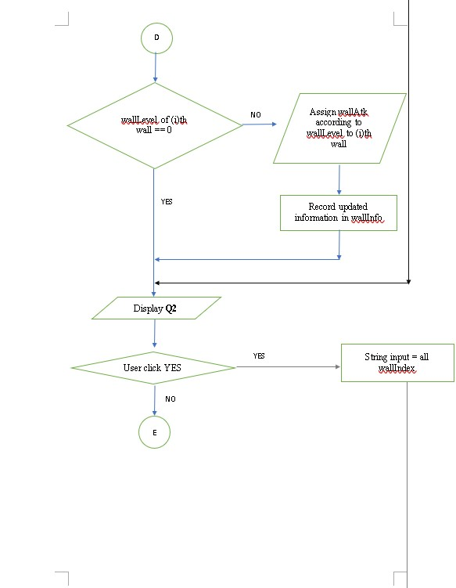

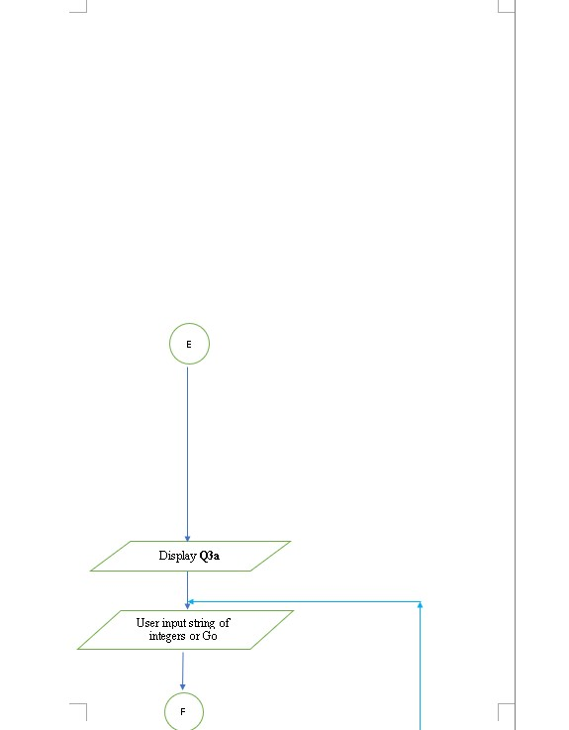

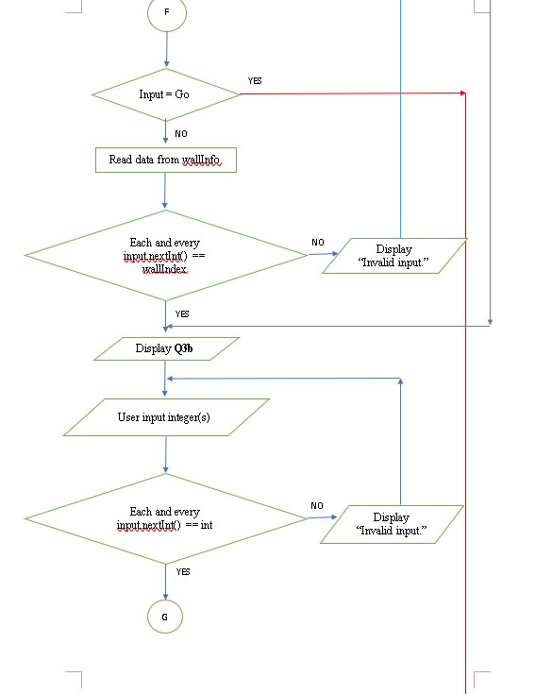

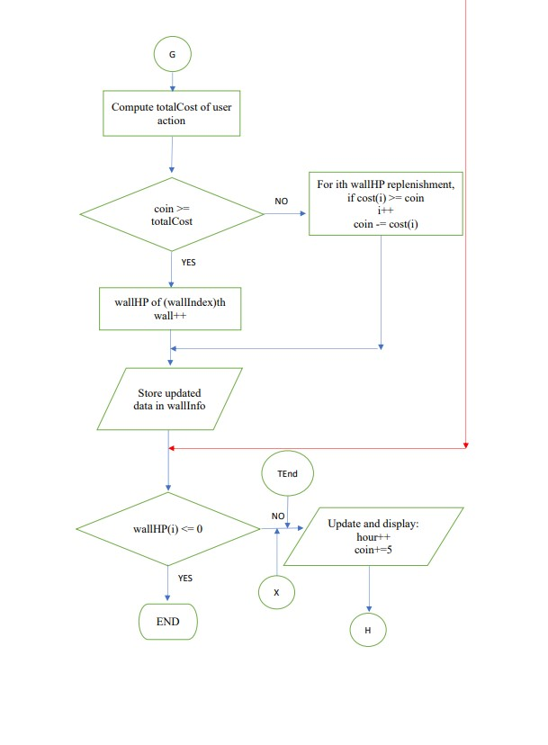

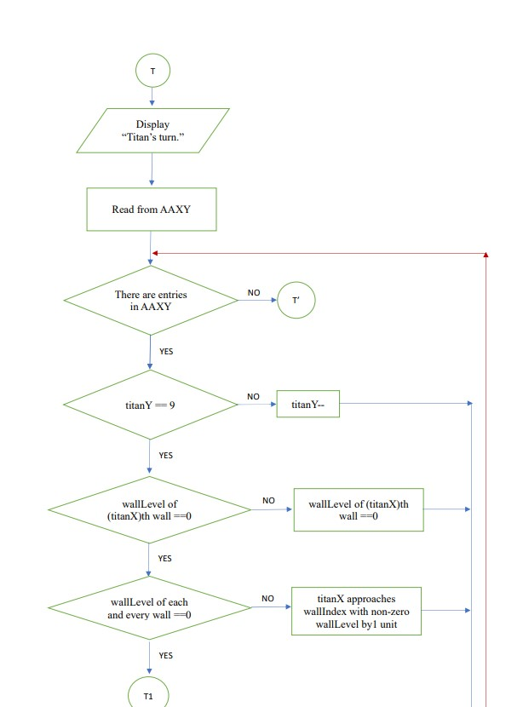

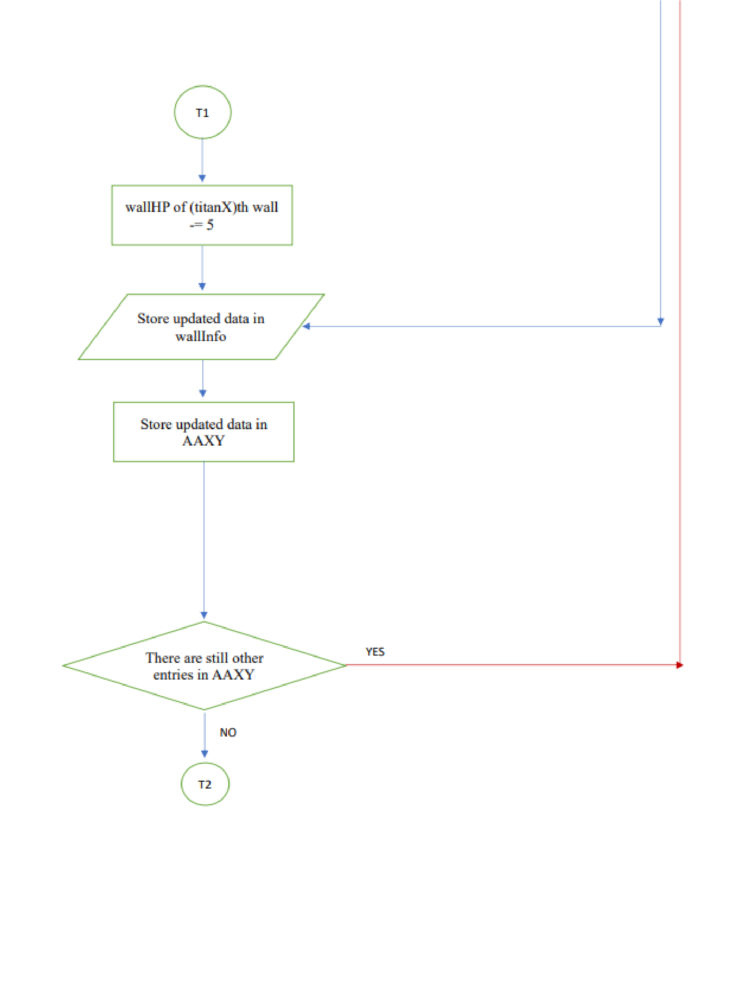

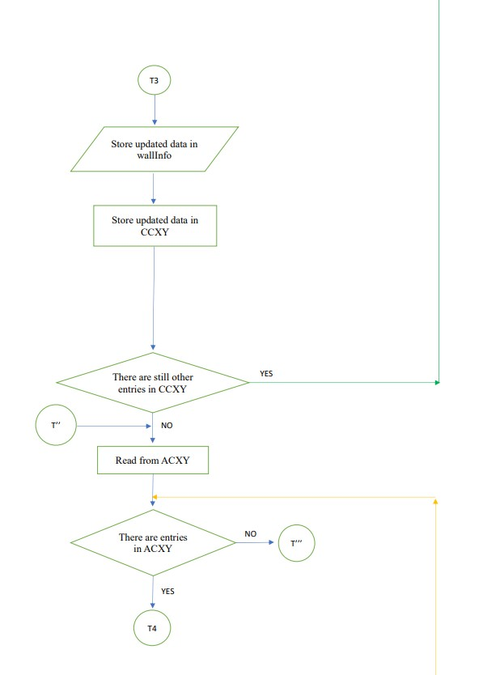

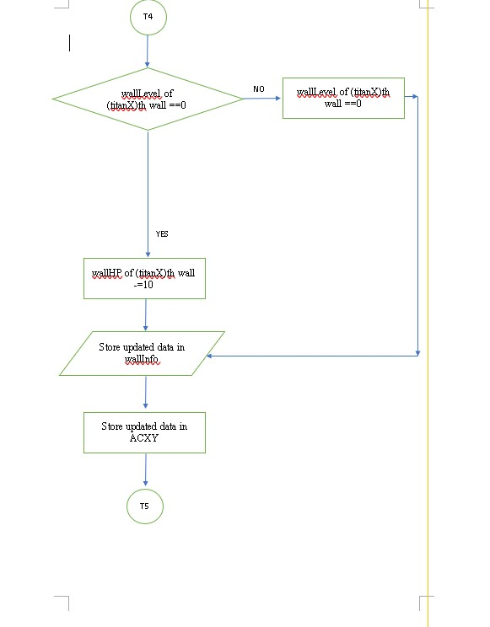

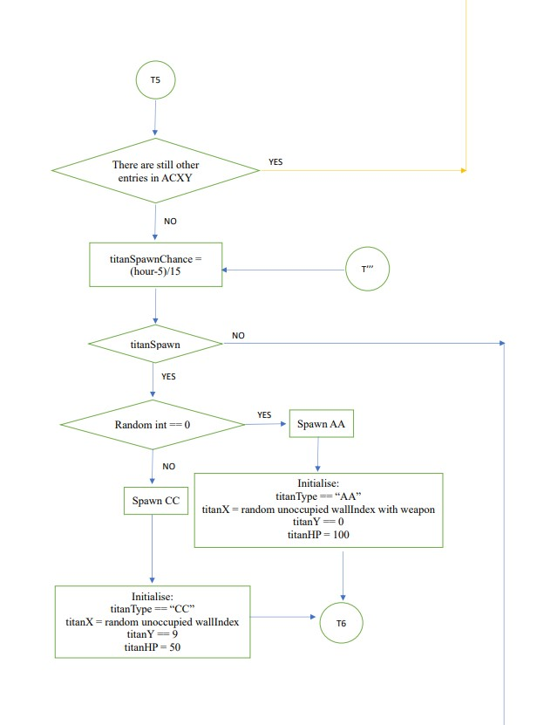

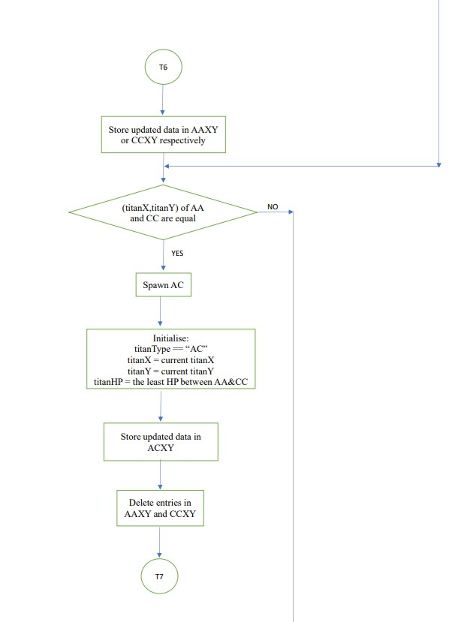

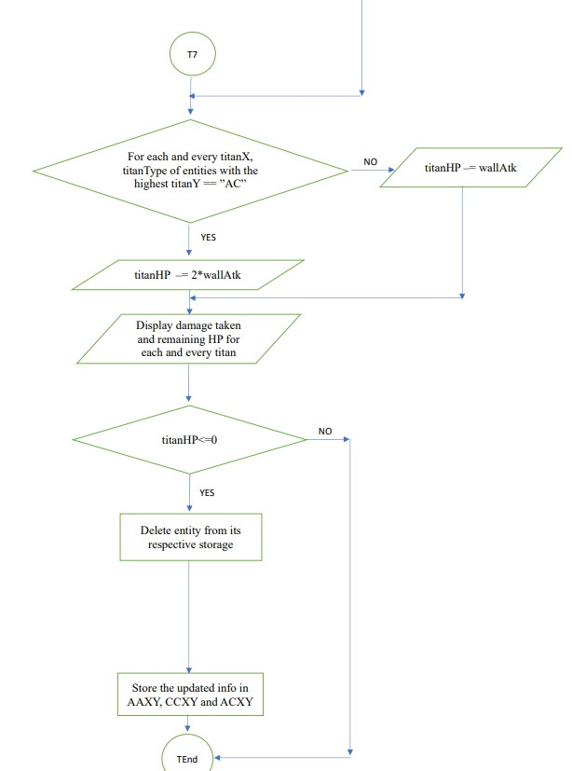

# GAMEPLAY SCREENSHOTS

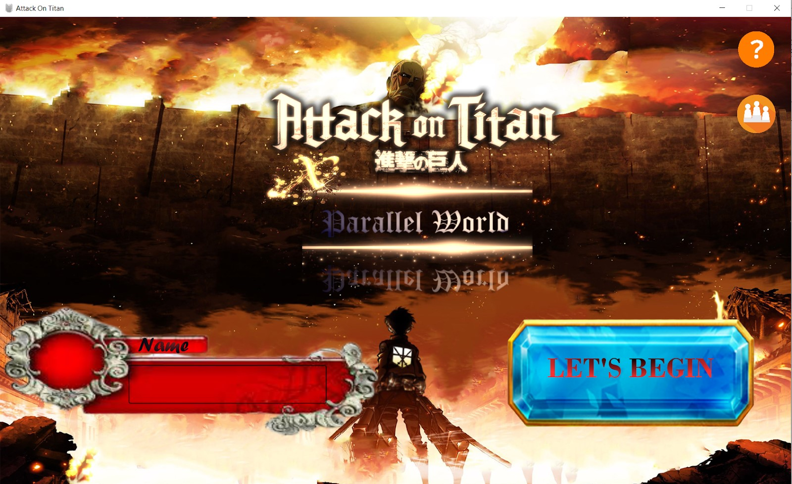

Our Main Menu

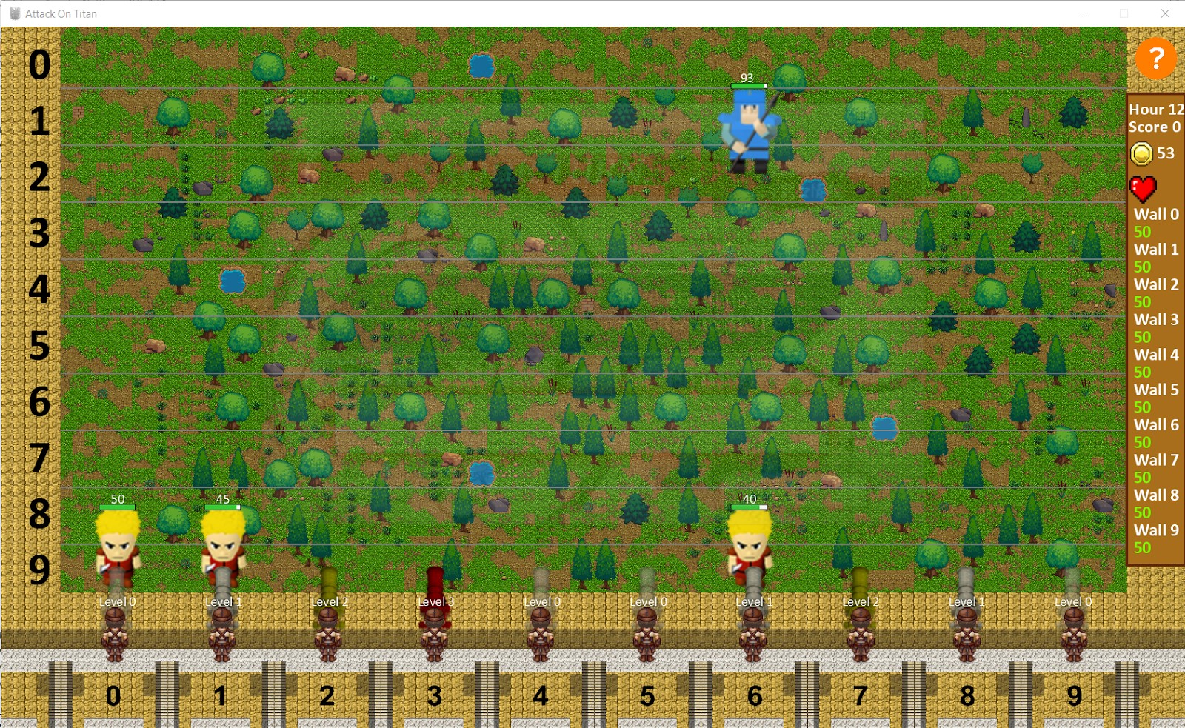

Map view of our game

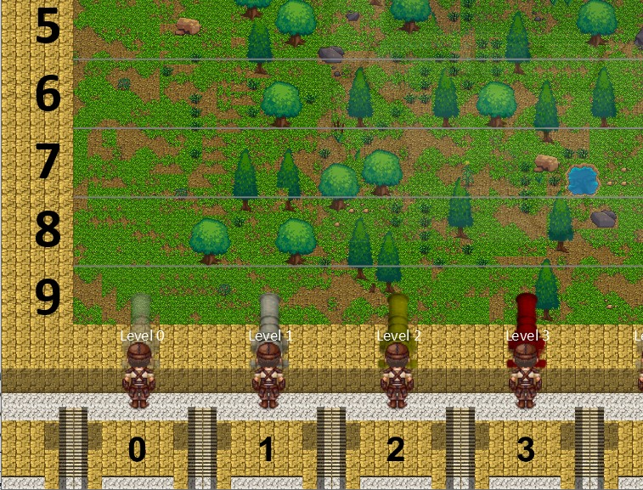

Different levels of cannons

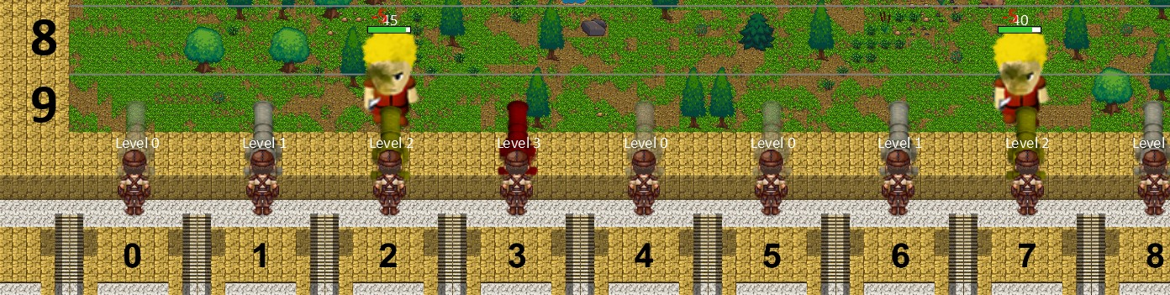

Cannon shooting a colossus titan

# SOURCE CODES

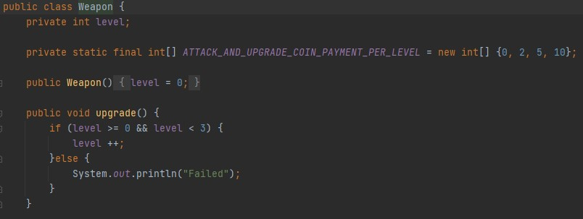

**Weapon.java**

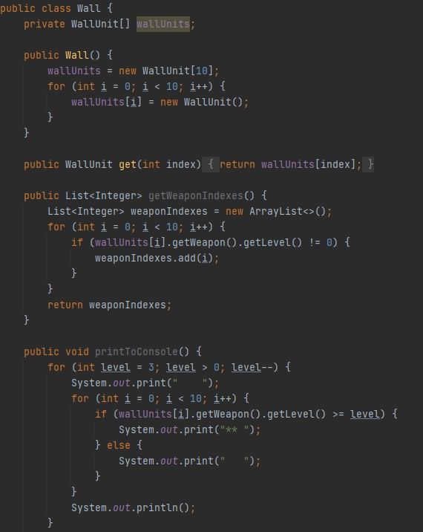

**Wall.java**

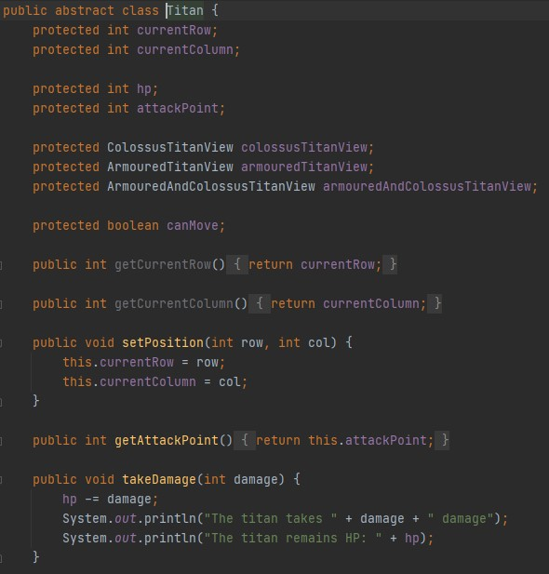

**Titan.java**

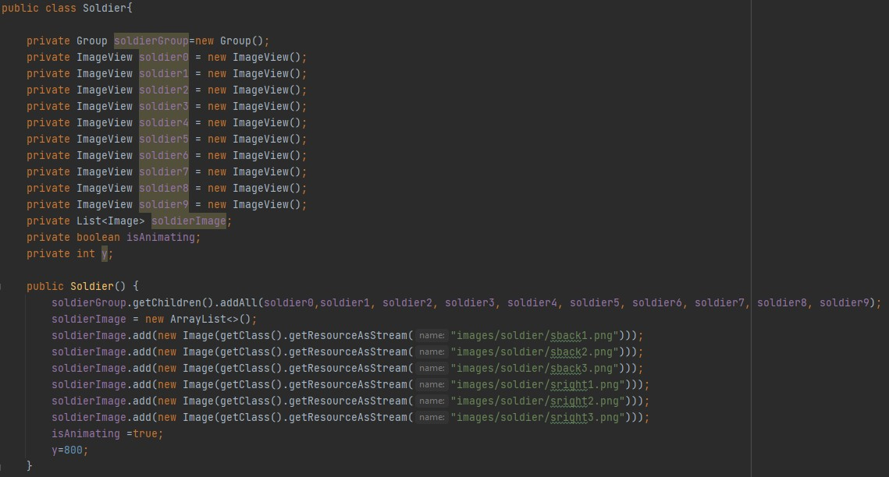

**Soldier.java**

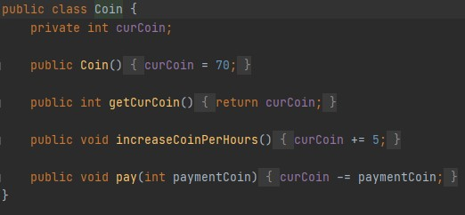

**Coin.java**

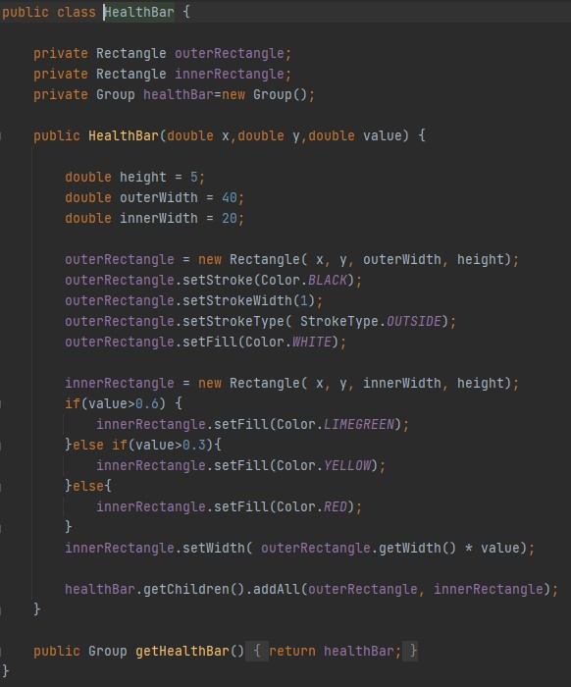

**HealthBar.java**

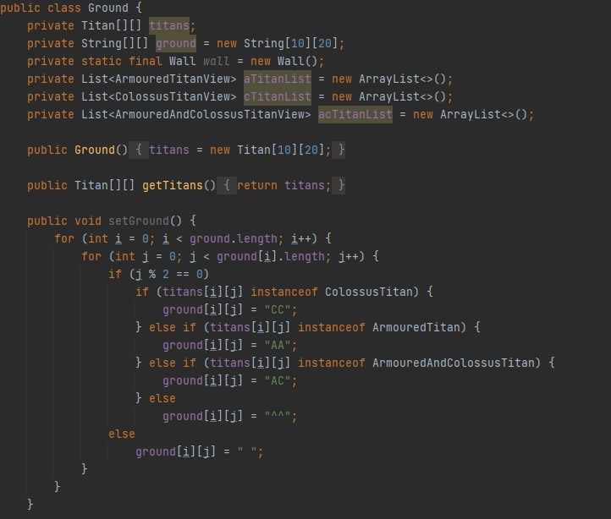

**Ground.java**

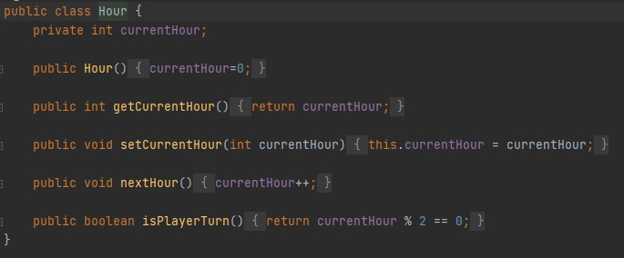

**Hour.java**

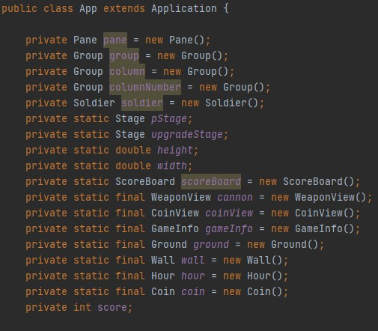

**App.java**

# APPENDIX

